Crawling [and scraping] multiple pages in a site you haven’t used before

I’m crawling and scraping through <https://www.transfermarkt.com/>, a site I’ve never scraped/crawled before. I’ve crawled and scraped multiple pages regarding 5 soccer leagues, all the teams within those leagues, and all the players within those teams.

Here are the caches

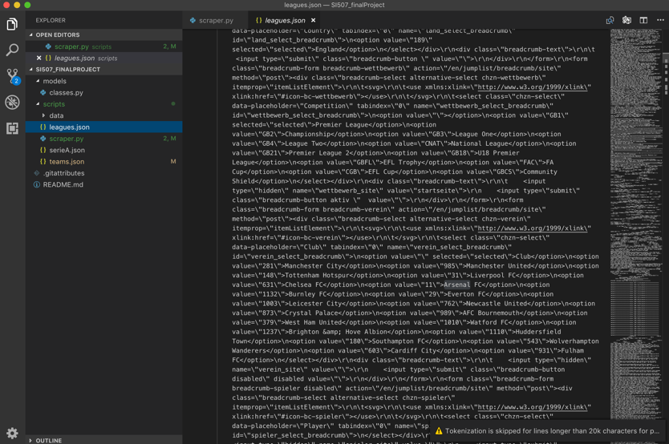

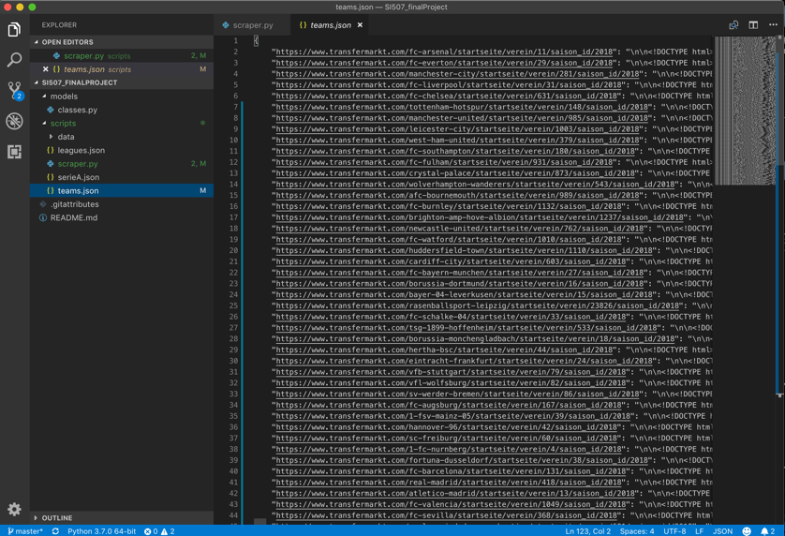

I created a CSV file from the Data. Here are those

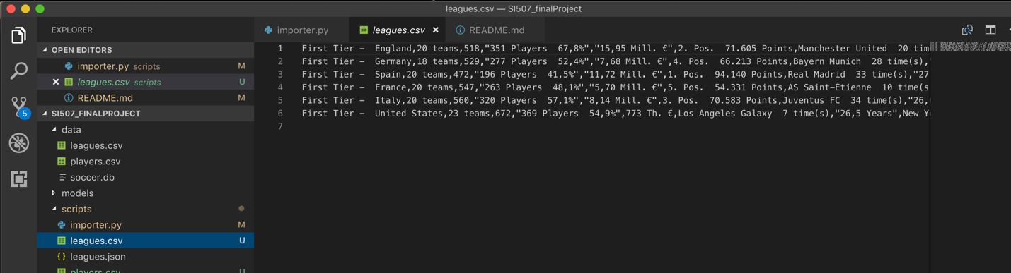

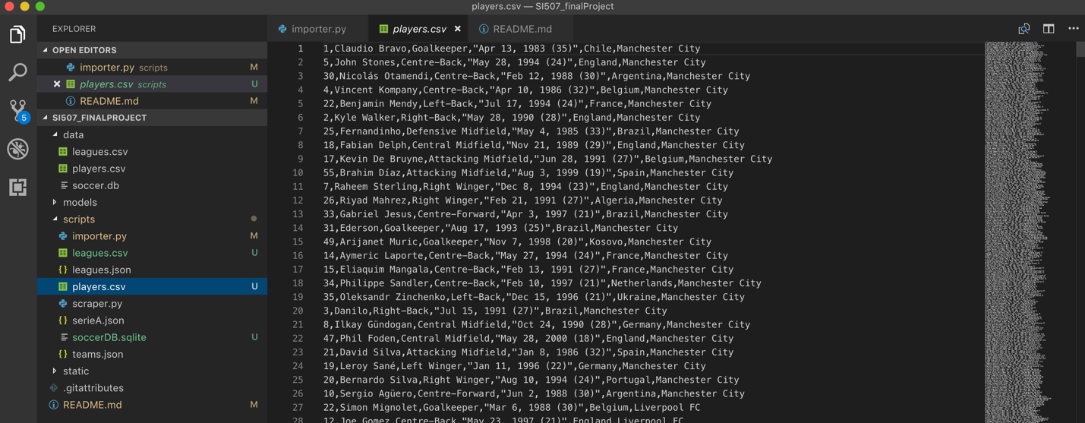And here are the databases I’ve created(so far)

